
MEMO TO PANEL

HUNTER AND CENTRAL COAST REGIONAL PLANNING PANEL

PANEL REFERENCE, DA NUMBER & ADDRESS | PPSHCC-255 - PAN-377087 – DA/2036/2023 -458-468 Main Road, Noraville NSW 2263
APPLICANT  OWNER | Trustee of the Roman Catholic Church for the Diocese of Broken Bay C/- DFP Planning - Trustee of the Roman Catholic Church for the Diocese of Broken Bay
APPLICATION TYPE | Development Application, Integrated (NSW Rural Fire Service)
REGIONALLY SIGNIFICANT CRITERIA | Clause 5, Schedule 6 of State Environmental Planning Policy (Planning Systems) 2021: Educational establishment with a CIV greater than $5 million
RECOMMENDATION | Approval
CIV | $9,286,000 (excluding GST)
DETERMINATION BRIEFING | 25 September 2024
PREPARED BY | Nathan Burr

DA/2036/2023 seeks approval for alterations and additions to an existing educational establishment. Further to the initial review of the assessment report the panel has sought further information and clarification with respect to a number of matters pertaining to flooding and car parking. It has also been revealed that a superseded plan set had been included as an attachment to the panel assessment report. These matters are discussed in detail below.

MATTERS RAISED
- Additional information is required with respect to the Flood Emergency Response Plan and additional information is required to address the particulars of clauses 5.21 and 5.22 of the Central Coast Local Environmental Plan 2022.

Nature of the Hazard
The site is slopes north away from the road frontage toward a naturally occurring wetland which is also partly within the northern extent of the subject site. A significant drainage feature of the site is an intermittent floodway that runs along the eastern portion of the site draining the wetland. The floodway is not a named watercourse. A secondary flow path exists through the central portion of the site which generally flows through the carpark and vehicular access area through to an open grassed sports area also eventually draining to the the wetland. The site is located relatively high the in the catchment.
The site is identified as being subject to flooding in the areas of the drainage lines. The flooding is associated with overland flow and is not influenced by lake or ocean flooding. In this regard the flood events experienced on the site are associated with rainfall events and the duration of the flood event is typically that of the storm, for the PMF flooding duration is expected to be in the order of 30 minutes.
The floodway along the eastern boundary of the site is located within an ecologically significant area of existing vegetation that is separated from normal school operations and students do not access the vegetated area and it is not part of the ordinary operation of the school. The floodway is identified as being high hazard however, given its isolation the school buildings and recreation area the floodway is considered to have a limited impact on either the existing or proposed development.
The flow path through the school area is subject to depths of 500-800mm in the PMF and approximately 350mm in the 1% AEP event. A PMF level of RL 11.23 was determined just upstream of the proposed building and has been adopted as the relevant level for the development.
Ordinarily to account for climate change a 30% increase in the 1% AEP level is applied and, in this instance, applying a 30% increase to the 1% AEP level results ina level that is lower than the PMF level therefore consideration of the PMF level may be taken to include consideration of potential climate change.
Flood depths in the PMF and 1% AEP events are depicted on the map extracts below.
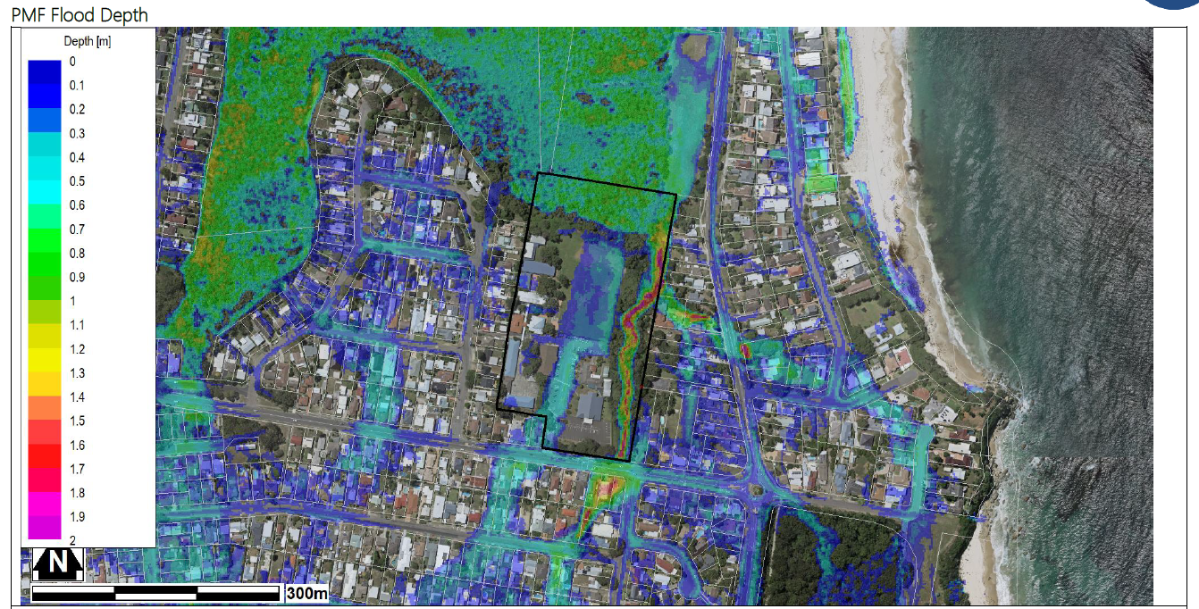
Figure 1 – PMF Flood Depth Map
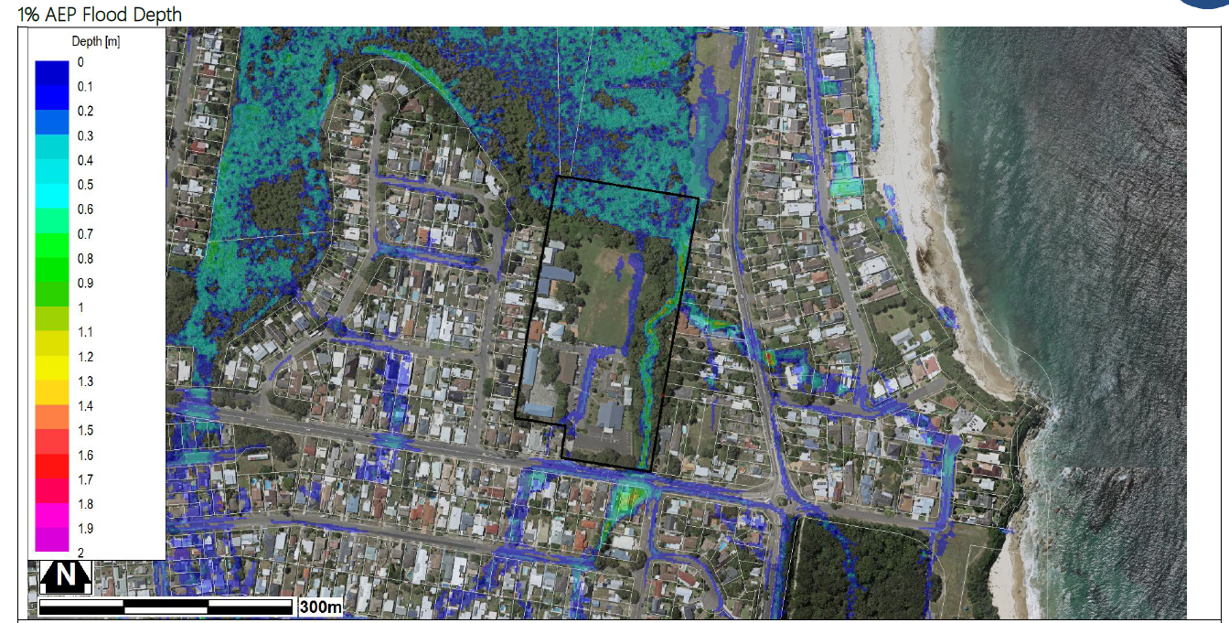
Figure 2 – 1% AEP Flood Depths
The hazard category of the site flooding of the site has been identified utilising the methodology summarised in the graph below where hazard is determined by including consideration of velocity and is therefore considered to be a better measure than depth alone.
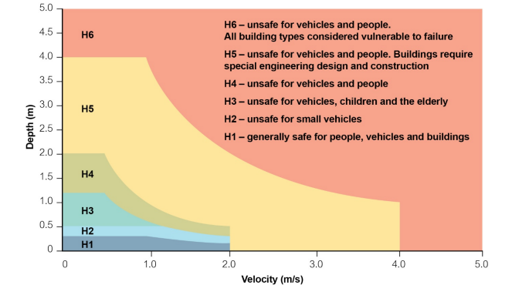
Figure 3 – Explanation of Hazard Categories – H1-H4 Low Hazard – H5-H6 High Hazard
The flow path affecting the school area is up to a H3 category in the PMF and H2 in the 1% AEP. Based on the hazard category the flooded areas of the site are considered to be unsafe for people in the PMF and may present difficulties for vehicular access in the 1% AEP event.
The flood hazard categories for the PMF and the 1% AEP flood events are depicted on the map extracts below.
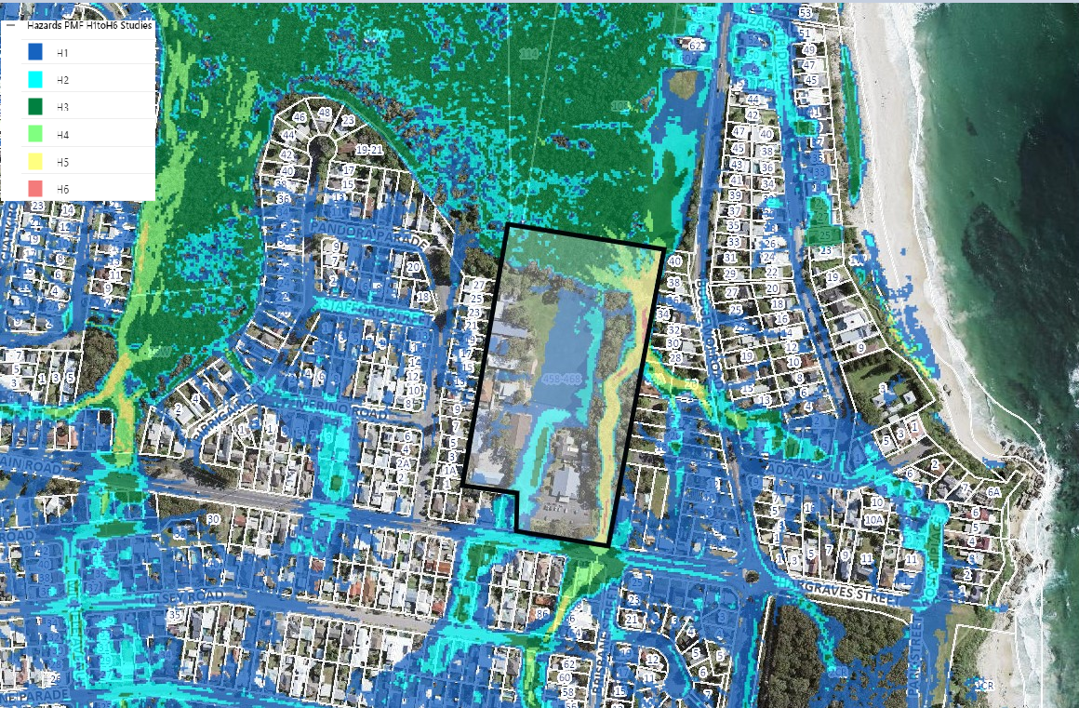
Figure 4 – PMF Hazard Categories

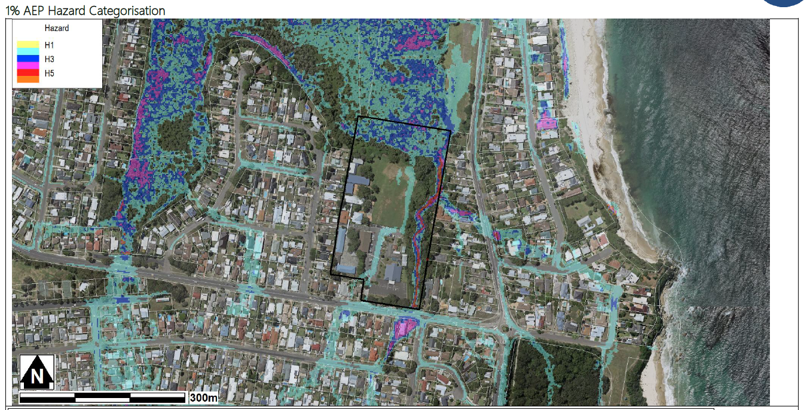
Figure 5 – 1% AEP Flood Hazard Categories

Proposed Development
The application is accompanied by a Flood Risk Management Report prepared by JN Responsive Engineering dated 06/06/2024.

The flood assessment report has adopted the PMF level of 11.23m AHD as the flood planning level. In this regard by adopting the PMF level as the flood planning level the flooding assessment and considerations adequately cover all events under the PMF including the potential impacts of climate change on flooding. In this regard it is noted that there are no peculiarities with respect to lesser events that would warrant additional consideration. In effect all flooding events are associated with rainfall events and the larger flooding events are driven by more intense rainfall events and aren’t subject to other influences for example, tides.

The finished floor level (15.92 m AHD) for the new building J is significantly higher than the PMF level of 11.23m AHD which means the building will remain flood free. A safe low hazard evacuation route is available to the west to Pandora Avenue in the event of a flood emergency.
Figure 6– PMF Extent and School Buildings – JN Report
The exisintg and propsoed development mitigates the flood risk to buildings by locating floor levels above the PMF level. Having buildings and portions of the site flood free also allows for occupants to refuge on site while either the storm event generating the flooding passes (as previously mentioned in the order of 30 minutes maximum) or prepare to evacuate via the low hazrd route identified to Pandora Parade.
The Flood Risk Management Report includes a Flood Emergency Response Plan (FERP) which is cinlcuded as an attachment. The FERP includes proceedures for Preparedness, Alert, Emergency Contracts, Evacuation, Actions Reponsilities and Proceedures, After the Food Event. In accordance with the FERP the flood response is triggered by warnings issued via the ordinary public outlets by the Beuarau of Meteoriology or State Emeergency Service (or other emergency service) and involves the removal of people where present from the low areas of the site to the buildings to await either the subsidence of the storm event or if evacuation of the site if so ordered by the State Emeergency Service or other emergency service.
An extract of the FERP is included below which details the steps to be taken during a PMF event
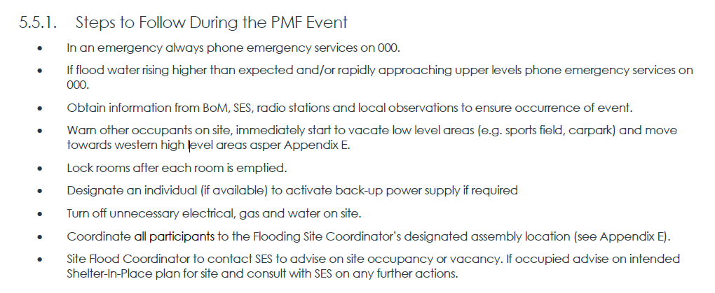
Figure 7 - FERP Extract – JN Enginieering
Statutory Considerations

CCLEP 2022 - Clause 5.21 – Flood Planning

The Flood Risk Management Report contains the following assessment of the provisions of clause 5.21(2) of the Central Coast Local Environmental Plan 2022 (CCLEP 2022) as tabled below:

Clause | Comments Pertaining to the Site
(2) Development consent must not be granted to development on land the consent authority considers to be within the flood planning area unless the consent authority is satisfied the development—
(a) is compatible with the flood function and behaviour on the land, and | The proposed additions and alterations to the school are considered Critical or Sensitive Facilities hence working towards the PMF flood level for any building levels. This development is compatible with the flood hazard of the land.
(b) will not adversely affect flood behaviour in a way that results in detrimental increases in the potential flood affectation of other development or properties, and | The proposed works are located outside the flood  extents and are not in any identified overland flow paths, therefore will not adversely affect other properties.
(c) will not adversely affect the safe occupation and efficient evacuation of people or exceed the capacity of existing evacuation routes for the surrounding area in the event of a flood, and | The development provides a safe refuge above the PMF level.
(d) incorporates appropriate measures to manage risk to life in the event of a flood, and | The development provides a safe refuge above the PMF level.
(e) will not adversely affect the environment or cause avoidable erosion, siltation, destruction of riparian vegetation or a reduction in the stability of river banks or watercourses. | The development has no significant impact on the nearby environment.

In deciding whether to grant consent the consent authority must consider the following matters as specified in clause 5.21(3) of CCLEP 2022 as tabled below:

Clause | Comments Pertaining to the Site
(3) In deciding whether to grant development consent on land to which this clause applies, the consent authority must consider the following matters—
(a) the impact of the development on projected changes to flood behaviour as a result of climate change, | The Flood Risk Management Report has adopted the PMF as the flood planning level which is considered to be inclusive of cliamte change considerations. There have been no changes to flood behaviour identified that would result from the proposed development.
(b) the intended design and scale of buildings resulting from the development, | The scale and nature of the proposed buildings and works are considered to be commensurate with the intended use and floor levels have been located above the PMF level. The proposed development and use of the site is considered to be commensurate with the flood hazard of the site.
(c) whether the development incorporates measures to minimise the risk to life and ensure the safe evacuation of people in the event of a flood, | The development application includes a FERP which is considered to adequately address the safe occupation of the site. The site and in particular the proposed development include areas that are completely flood free and are of themselves a measure to minimise the risk to life in the event of a flood.
(d) the potential to modify, relocate or remove buildings resulting from development if the surrounding area is impacted by flooding or coastal erosion. | The proposed buildings incorporate floor levels above the PMF which is considered to adequately address flood risk to the development and there are no changes to flood behaviour resulting from the development that would otherwise require mitigation elsewhere as a result of changes to flood behaviour or erosion or the like.

The proposal does not increase the risk to life or impact to the existing evacuation requirements and the design generally avoids impacting on flood behaviour, hence the proposal is supported. In this regard, the Panel can be satisfied that the proposed development, subject to conditions:
(a) is compatible with the flood function and behaviour on the land, and
(b) will not adversely affect flood behaviour in a way that results in detrimental increases in the potential flood affectation of other development or properties, and
(c) will not adversely affect the safe occupation and efficient evacuation of people or exceed the capacity of existing evacuation routes for the surrounding area in the event of a flood, and
(d) incorporates appropriate measures to manage risk to life in the event of a flood, and
(e) will not adversely affect the environment or cause avoidable erosion, siltation, destruction of riparian vegetation or a reduction in the stability of river banks or watercourses.

Clause 5.22 – Special Flood Considerations

An educational establishment is defined by clause 5.22 as a sensitive and hazardous development and pursuant to clause 5.22(2)(a) this clause applies to land that is above the flood planning level and below the PMF. In accordance with clause 5.22(3) development consent must not be granted to development on land the consent authority has considered the matters as tabled below:

Clauses | Comments Pertaining to the Site
(3) Development consent must not be granted to development on land to which this clause applies unless the consent authority has considered whether the development
(a) will affect the safe occupation and efficient evacuation of people in the event of a flood, | The existing and proposed buildings have floor levels above the PMF and the area affected by flood is comprised of outdoor play spaces and vehicle access and parking areas. The flood events experienced on the site are short duration events that typically last for the during of the storm event generating the flooding and flood water subside relatively rapidly. The development includes a FERP that requires occupants of the site to relocate to safe building during storm events/flood warnings and the site may be safely occupied. If the site is to be evacuated there is a low hazard evacuation route identified to Pandora Parade. The proposed development creates an additional flood free building to accommodate occupants on the site but will otherwise not have a detrimental affect on flooding or flood risk.
(b) incorporates appropriate measures to manage risk to life in the event of a flood, | The development application includes a FERP which is considered to adequately address the safe occupation of the site. The site and in particular the proposed development include areas that are completely flood free and are of themselves a measure to minimise the risk to life in the event of a flood.
(c) will adversely affect the environment in the event of a flood. | The proposed development will not affect the existing flood regime and will not alter the hydrology of the nearby wetland or result in other impacts such as erosion.

The flood assessment of the application has considered the implication of the PMF and found that the development is satisfactory in terms of the heads of consideration under clause 5.22, namely the development will not affect the safe occupation and efficient evacuation of people in a flood event, subject to the conditions of consent incorporates satisfactory measures to manage the risk to life in the event of a flood and will not adversely affect the environment in the event of a flood. The Panel can be satisfied the provisions of clause 5.22 have been met.

- The Panel requires additional analysis of car parking between the co-located facilities i.e. the schools and the church. The assessment needs to be specific in terms of different operating times and how the different uses are managed.

The applicant has provided the following explanation of the parking arrangements for the development.

As outlined in the DA Traffic Report, the school generally operates between the hours of 7:00am and 6:00pm, Monday to Friday. The core school hours are from 8:30am to 3:15pm.

The church, known as “Our Lady of Perpetual Succour Catholic Church Toukley” is subject to the following regular services:

• Monday-Thursday: 9:00am
• Friday: 9:15am and 11:00 am on 1st Friday of each month (except January)

• Saturday: 9:00am and 6:00pm
• Sunday: 7:30am, 9:00am and 6:00pm

Additionally, the following services are also provided throughout the year:

• First Friday Night Mass Vigil: 7:00pm to 1:30am (except January)
• Reconciliation: Saturday 9:30am

No changes are proposed to the existing approved church. Nevertheless, the Central Coast Development Control Plan (DCP) 2022, Chapter 2.13, provides the parking rates for places of worship as follows:
• Places of public worship are required to provide 1 space per 20m2 GFA or 1 space per 10 seats, whichever is greater.
The church which has a maximum seating capacity of 500 persons, nominally requiring a total of 50 parking spaces.

Weekday Church Use
As outlined above, the operation of the church primarily occurs over the weekend on Saturdays and Sunday, with smaller services offered during the week outside of peak school drop-off/pick-up hours. It should be noted that the school peak pick-up demands (100 spaces at 3pm-3:15pm) associated with the expansion do not coincide with the weekday church services, thus, demands are unlikely to be 130 spaces (post DA parking quantity) at once. In summary, the weekday school peak and external weekday church uses do not coincide, and sufficient on-site car parking is provided for both uses.

Weekend Church Use
During the weekends, the school is not operational, thus all 130 car parking spaces will be available for church use. The provision of 80 spaces over the minimum DCP requirement will assist in alleviating on-street parking demands on weekends. Additionally, it is reiterated that the proposed DA does not seek to make any physical or operational changes.

- The Panel want to understand the existing / proposed drop off and pick up arrangements.

The applicant has provided the following in relation to on-site vehicle manoeuvring arrangements.

As outlined in Section 4.3.1 of the DA Traffic Report, the school currently accommodates 133 off-street parking spaces. On-site spaces are not designated, and 133 spaces are currently available for all staff, student drop-off/pick-up, visitors, and church use. Staff typically park within the northern car parking spaces, allowing students to be dropped-off/picked-up in spaces closer to Main Road. No changes are proposed to the existing DOPU arrangements with the off-street car park providing sufficient capacity for the proposed expansion (+90 students and +5 staff).

- The Panel want a factual understanding of how much street parking is being relied upon.

The applicant has provided the following clarification with respect to the quantum of parking provided on-site in the context of parking demand.

Based on the existing on-street car parking survey, there appears to be demand for 10 parking spaces in the AM (8:30-8:45am) and 21 parking spaces in the PM (3:15-3:30pm). Whilst the surveys could not distinguish between school vehicles and residential vehicles, it is conservatively assumed that these vehicles are all associated with the school. Based on existing on-site usage, the post expansion on-site demands equate to 100 spaces, comprising 44 staff spaces and 56 student DOPU spaces. The development proposes 130 on-site spaces, 30 spaces above expected demands.

Should there be a change in parent/carer DOPU behaviour, there is spare on-site capacity to accommodate existing on-street demands (approx. 10-21 spaces). It should be noted that Council’s DCP allows Primary School DOPU spaces to be accommodated on-street, as shown in the extract below. It is also worth noting that the proposal requires 135 spaces under Council’s DCP controls, thus, the proposal is generally consistent with Council’s requirements.

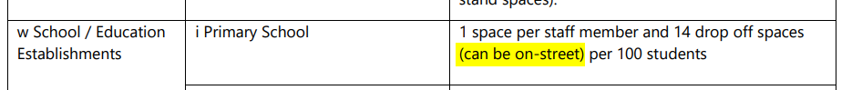

The development application contends that the parking provided on-site is sufficient to service the proposed development. The proposed development does include the removal of three spaces for the purposes of fire truck access as depicted in the plan extract below. The proposal has a numerical deficiency on-site in terms of DCP compliance however, the application has also demonstrated a quantum of street parking that is typically available during peak times that could be taken to serve the development for DCP compliance. In this regard the development does not seek to rely on street parking but by virtue of the street parking it is considered that that the development complies with the DCP.

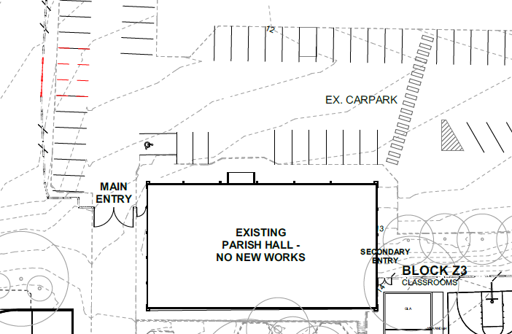

ADDITIONAL MATTERS
- Incorrect Plan Set
The assessment report tabled for the Panel’s consideration and associated draft conditions inadvertently refer to a superseded set of plans. A revised set of plans was received in March 2024 and accepted for assessment by the Council. The amended plans were NOT renotified pursuant to clause 1.2.2.10 of Chapter 1.2 Notification of Development Proposals of the DCP as the amendments are minor and do not result in any additional impacts.
The applicant’s statement detailing the plan amendments, and the amended plans are included as attachments.
Condition No. 1.1 requires updating to reflect the references to the amended plans. A revised set of draft conditions reflecting the corrected plan references has been included as an attachment.
- Applicant’s Requested Amendments to the Draft Conditions
The applicant has requested the insertion of ‘the relevant’ in place of a reference to ‘a’ in all instances within the conditions with respect to a reference to either Construction Certificate or Occupation Certificate. The proposed change to the conditions is considered to be minor in nature and alleviates potential confusion arising where there are multiple Construction Certificates and multiple Occupation Certificates associated with the development. The requested change has been incorporated into the revised draft conditions attached to this memo.
CONCLUSION
The proposed development is considered to adequality address the considerations under clauses 5.21 and 5.22 of the CCLEP 2022 subject to the recommended draft conditions below.
Prior to Occupation
5.11. Prior to the issue of any Occupation Certificate, the Plan of Management for St Mary’s Catholic Primary School is to be updated to incorporate the recommendations of the Flood Risk Management Report prepared by JN Responsive Engineering dated 06/06/2024, measure to comply with the General Terms of Approval issued by the NSW Rural Fire Service ref. DA20231115005166-Original-1 dated 29 January 2024, provision to prevent pedestrian access to the site via No. 11 Pandora Parade Noraville NSW except in the case of emergencies. This plan must incorporate any applicable regulatory requirements and/or recommendations.
Ongoing
6.5. The Flood Emergency Response Plan applicable to the site is to be updated annually, in consultation with the NSW State Emergency Service, to incorporate any applicable new and/or revised regulatory requirements and/or recommendations, and any changes to flood levels applicable to the site due to updated flood modelling and/or climate change impacts.

6.6. The operational of the school is to be in accordance with the approved Plan of Management as amended in accordance with this consent. For clarity, the School shall accommodate a maximum of 630 students and 54 staff at all times.
The proposed parking and access arrangements are considered to be satisfactory, and approval of the development is recommended subject to the revised recommended draft conditions.
Attachments:
- Flood Risk Management Report prepared by JN Responsive Engineering dated 06/06/2024.
- Applicant’s Cover Submission detailing plan amendments dated 19 March 2024.
- Revised Recommended Draft Conditions.
- Amended Plans Received 19 March 2024.

